Ideation Phase
Define the Problem Statements

Date | 01 July 2026
Team ID
Project Name | STOCK TRADING APP
Maximum Marks | 2 Marks

Customer Problem Statement Template:
Many beginners find stock trading platforms difficult to understand and risky because they involve real money. Users also need an easy way to manage investments, track transactions, and monitor profit or loss. The Stock Trading App provides a simple and secure platform where users can practice buying and selling stocks, manage their portfolio, and view transaction history through an easy-to-use dashboard. This helps users learn stock trading without financial risk.
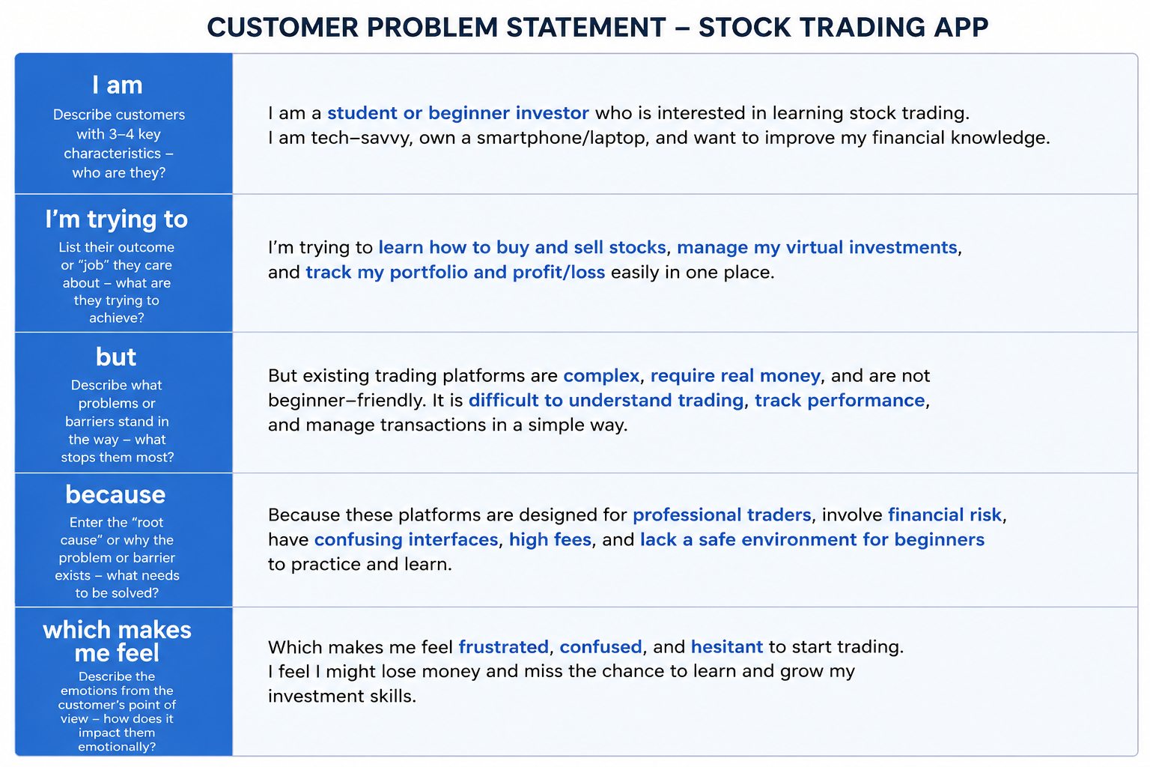

Example:

Problem Statement  (PS) | I am (Customer) | I’m trying to | But | Because | Which makes me feel
PS-1 | A beginner investor or student interested in learning stock trading. | Buy and sell stocks and manage my portfolio easily. | Existing trading platforms are complex and difficult for beginners. | They are designed mainly for experienced traders and involve real money. | They are designed mainly for experienced traders and involve real money.
PS-2 | A user who wants to track investments in one place. | Monitor my portfolio, transaction history, and profit/loss. | t is difficult to manage all investment details manually | There is no simple platform for organized portfolio tracking | Frustrated and worried about managing my investments accurately.

